|  |
| --- |
| **UNIVERSITY MALAYSIA TERENGGANU**  **FACULTY OF OCEAN ENGINEERING TECHNOLOGY & INFORMATICS**  **[CSM3103]**  **FRONT-END PROGRAMMING**  **LAB REPORT**  **[Lab 6]**  **Prepared by:**  Muhammad Irfan Hakim bin Saharul Redzuan  (S62113)  **Prepared for:**  Dr. Rabiei b. Mamat  [**BACHELOR OF SCIENCE COMPUTER(MOBILE COMPUTING)** ]  SEMESTER II 2022/2023 |

**Task 1**

Source code (index.html)

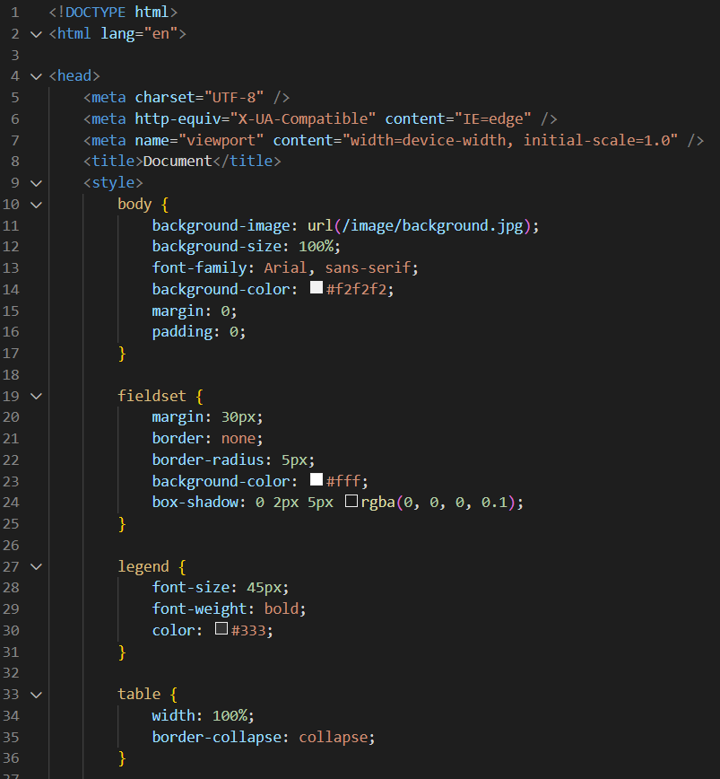

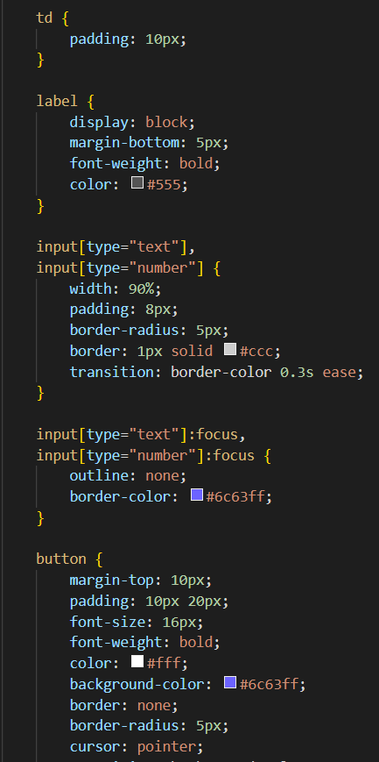

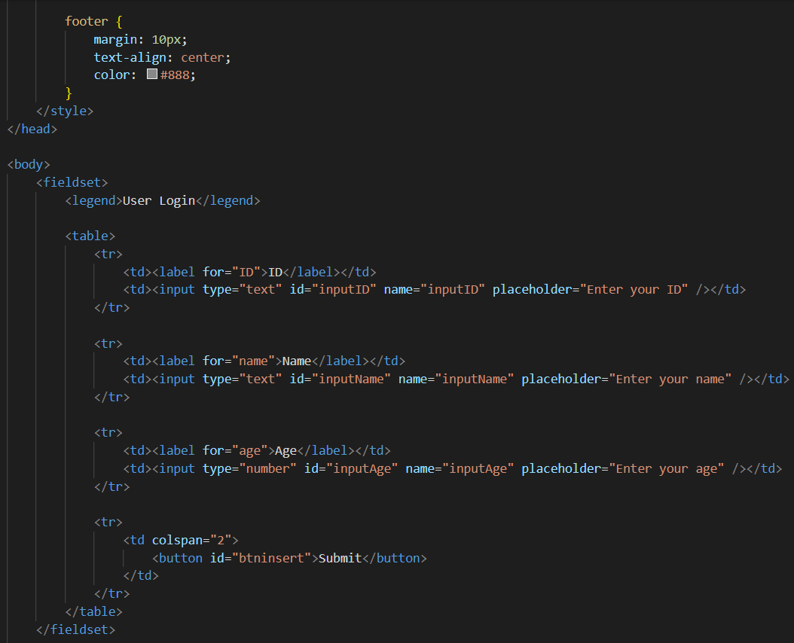

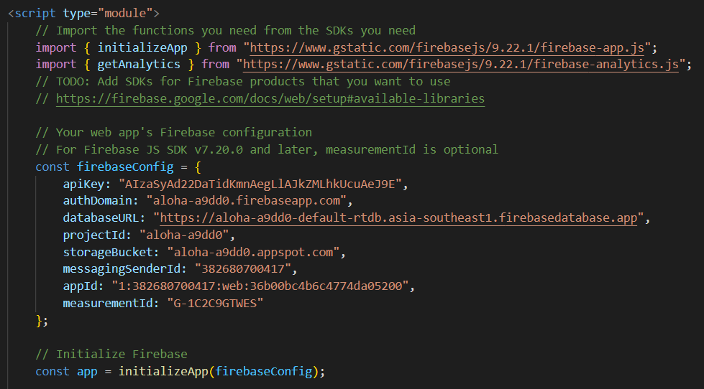

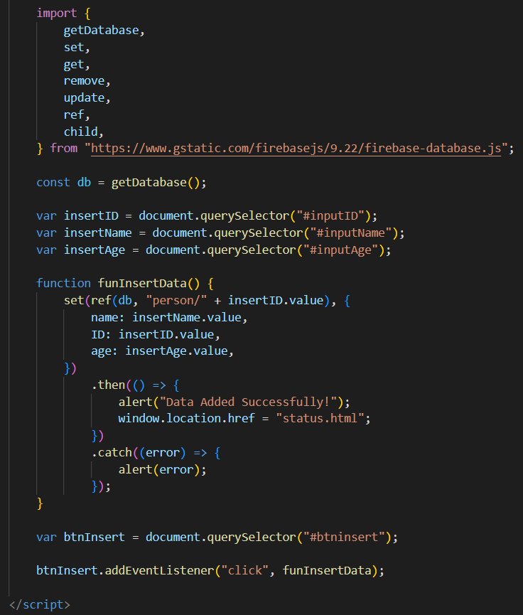

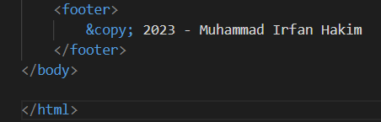

Status.html

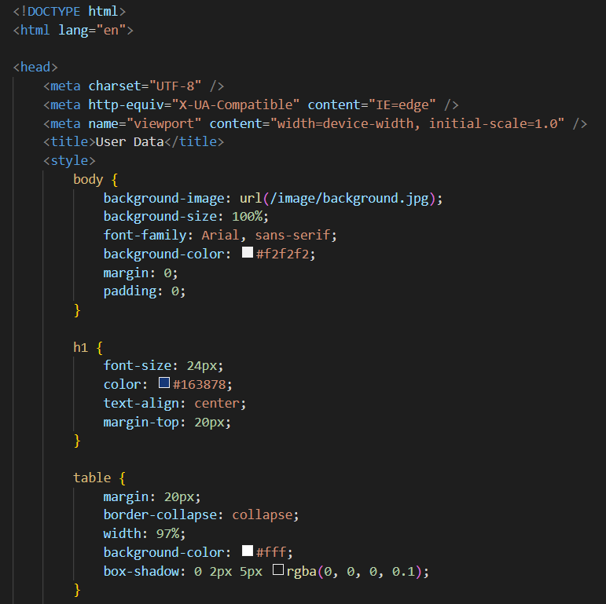

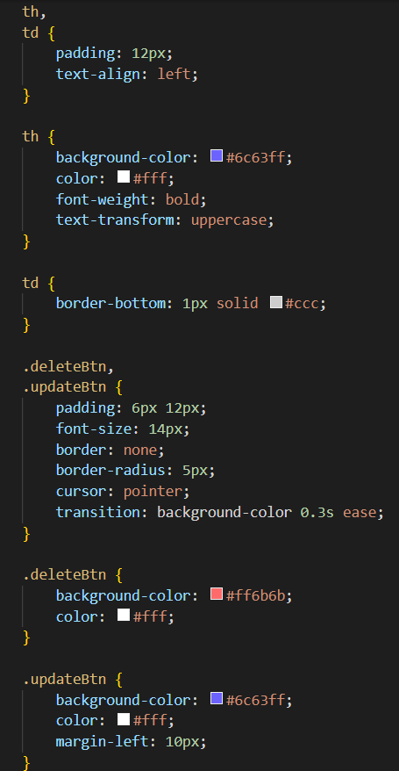

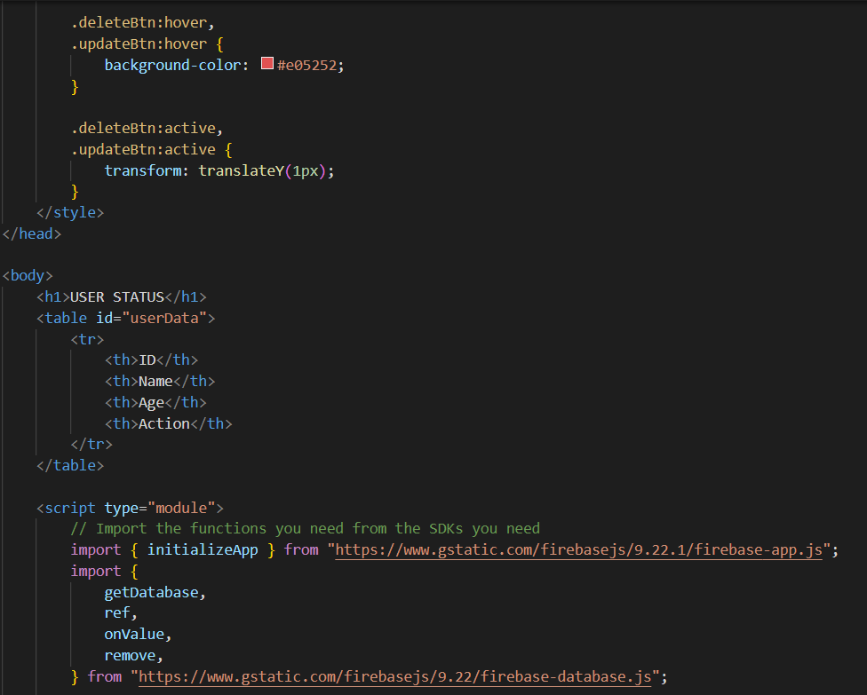

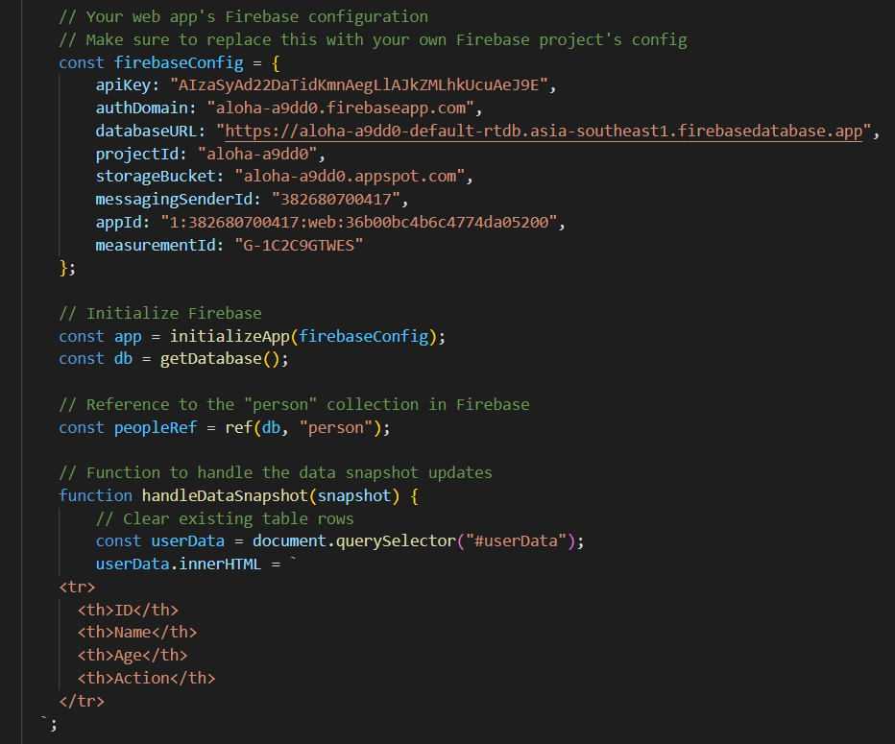

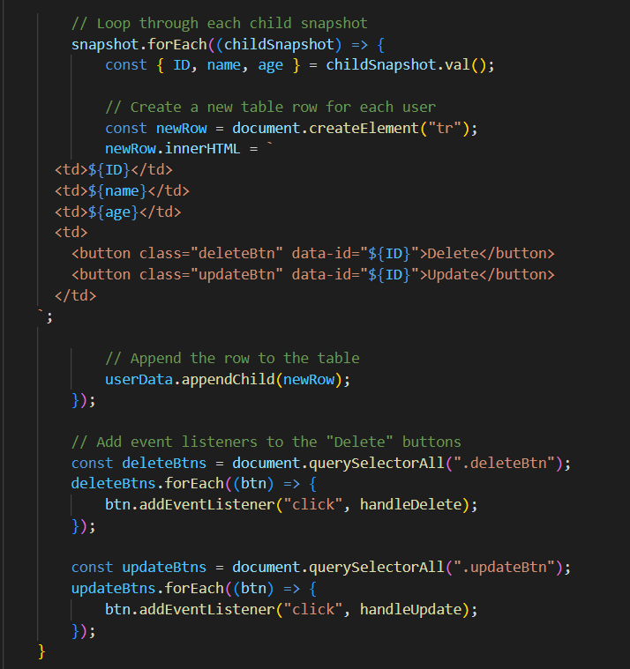

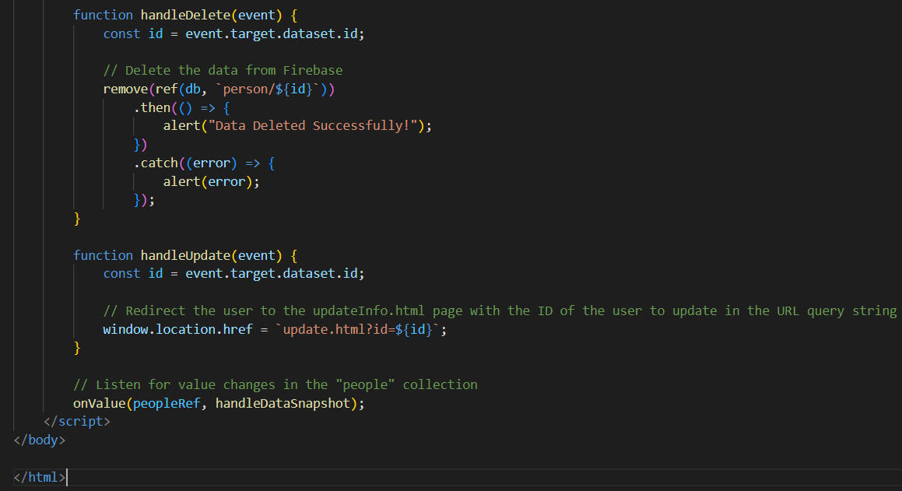

Update.html

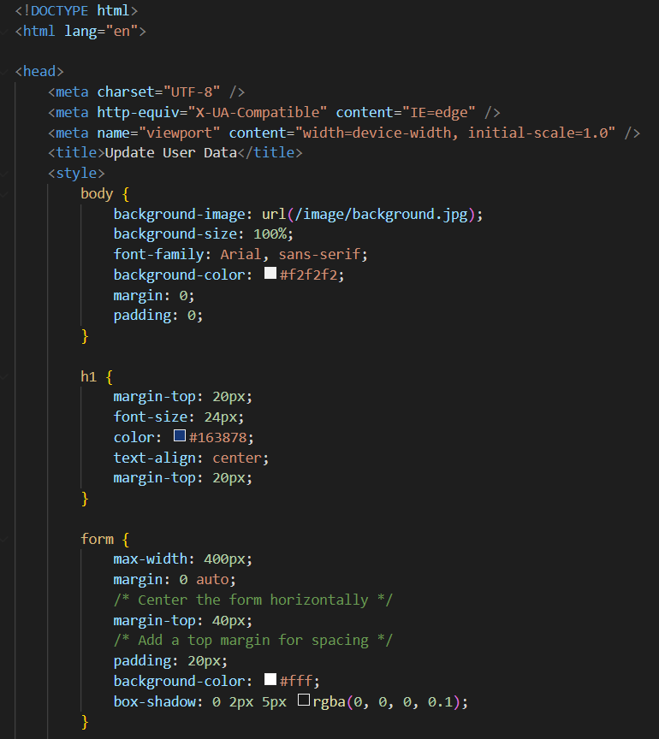

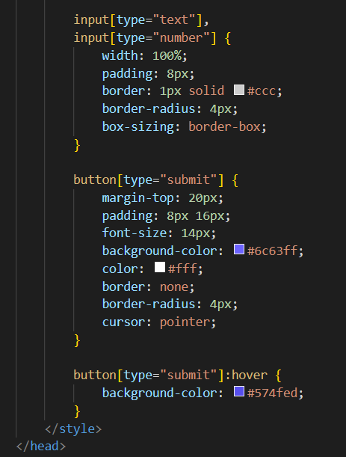

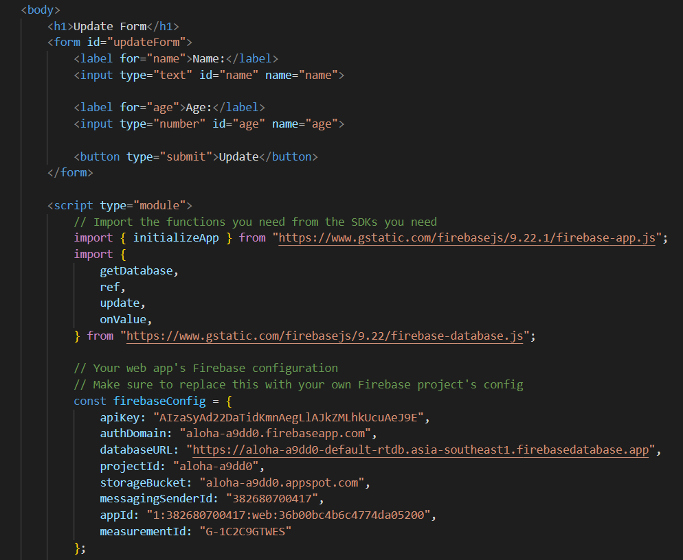

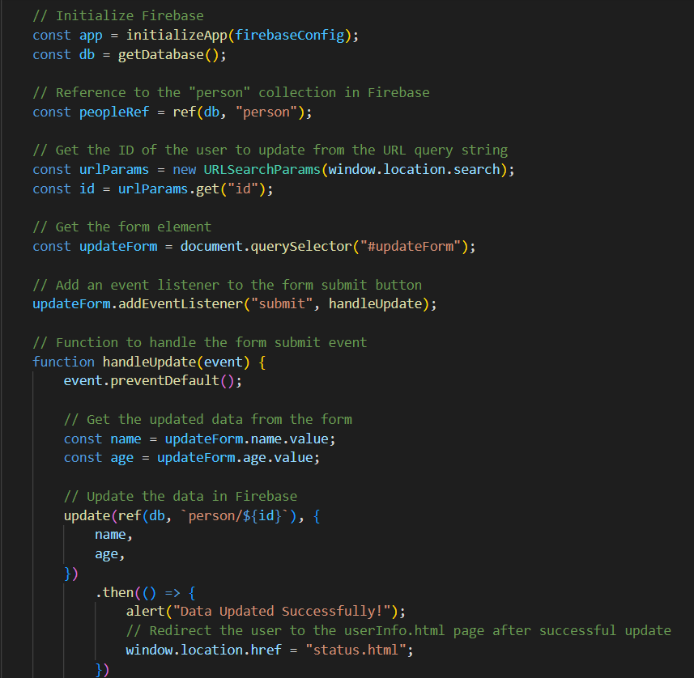

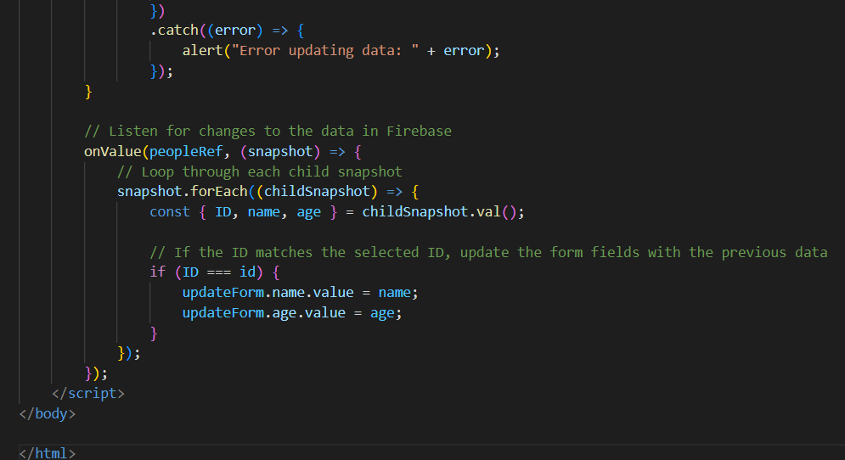

Output :

User login page

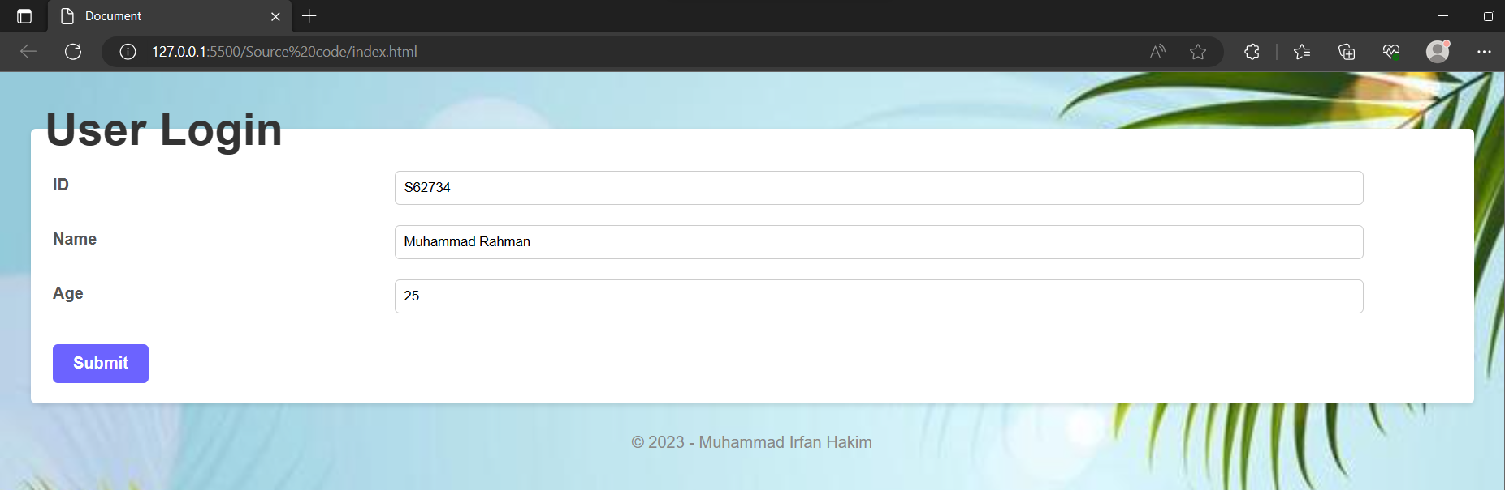

User data page

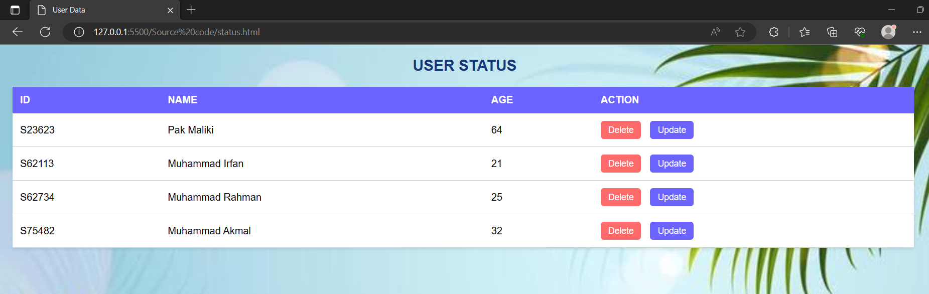

Update page

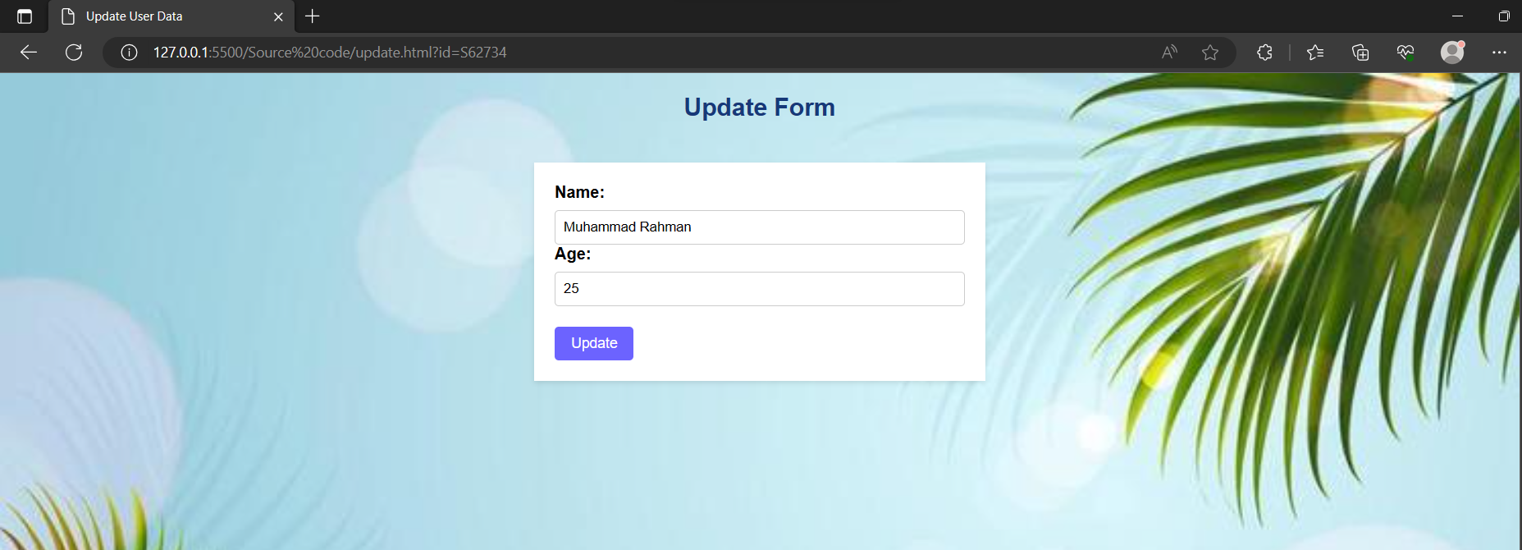

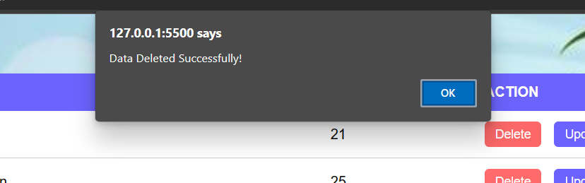

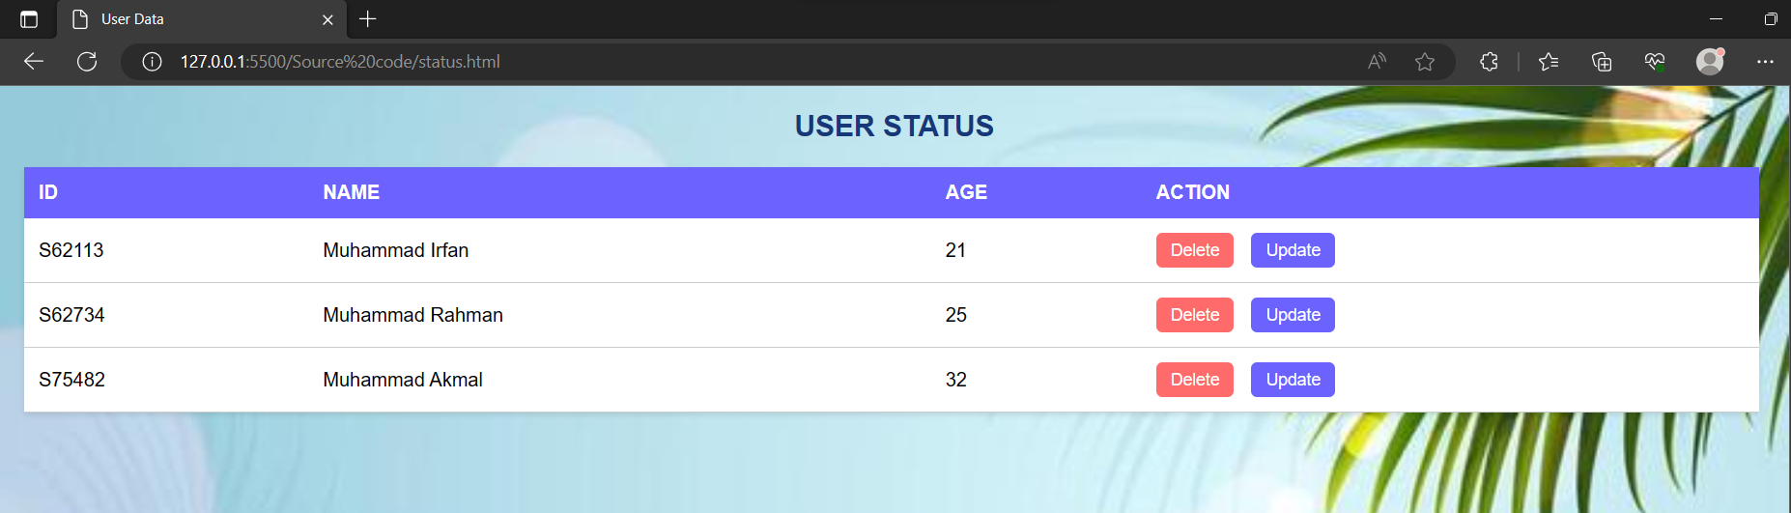

Pak Maliki data have been deleted

In firebase database

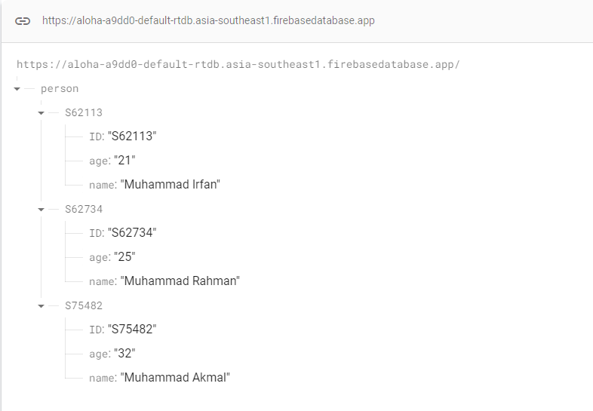

**Github link**

<https://github.com/Ifnhkm/S62113-Front-End.git>